CLOUD COMPUTING CONTINUOS ASSESSMENT 1

ABINAYA S

727721EUIT002

[727721euit002@skcet.ac.in](mailto:727721euit002@skcet.ac.in)

QUESTION 1

CREATE THE EC2 INSTANCE WITH THE FOLLOWING REQUIREMENTS.

1. INSTANE NAME

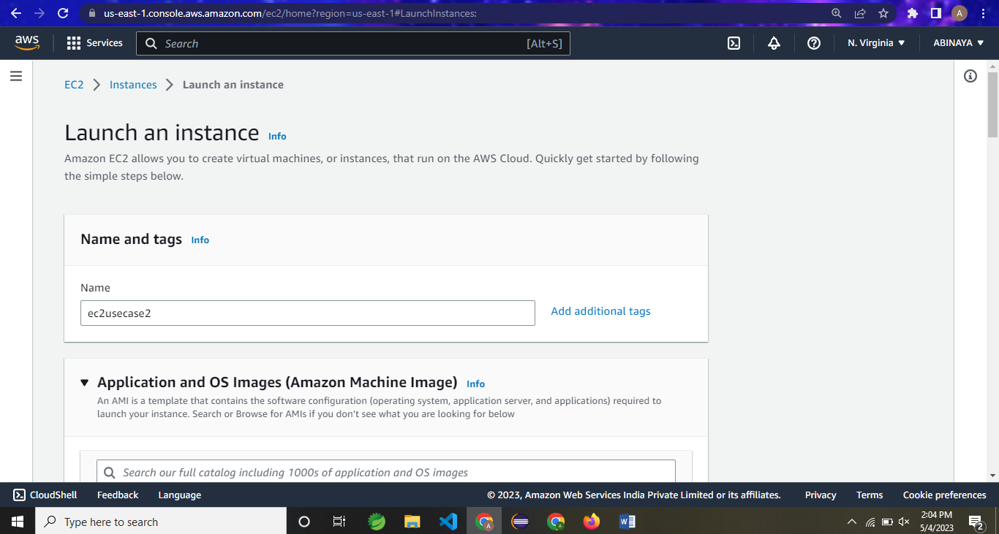

KEY PAIR NAME

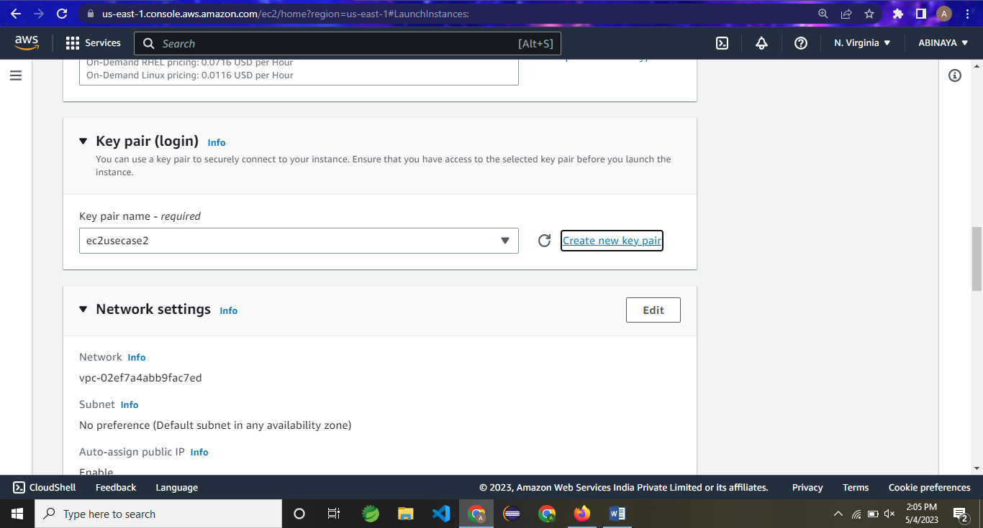

1. SELECT THE AMI LINUX

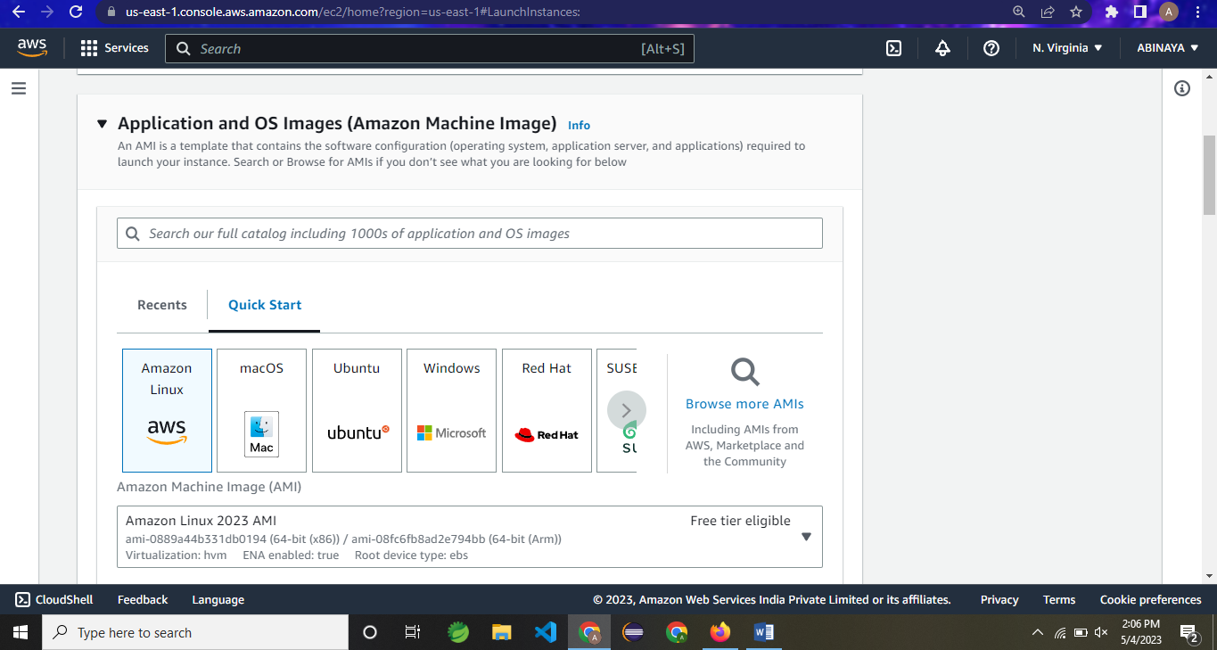

1. Increase a volume of 10GB

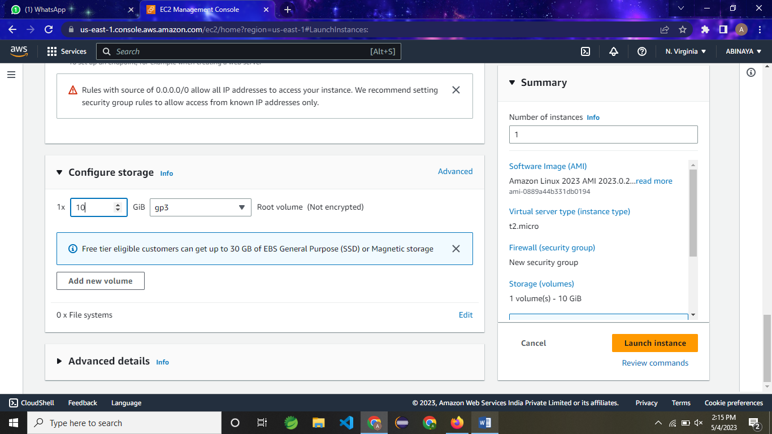

iv)

PORT NUMBER : 22 SSH IS ENABLE

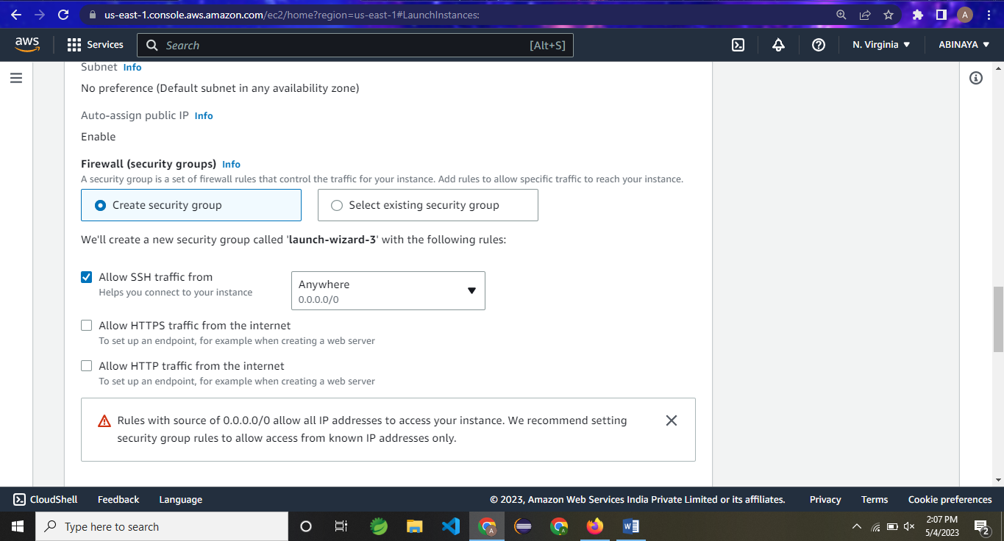

LAUNCH A INSTANCE STATUS

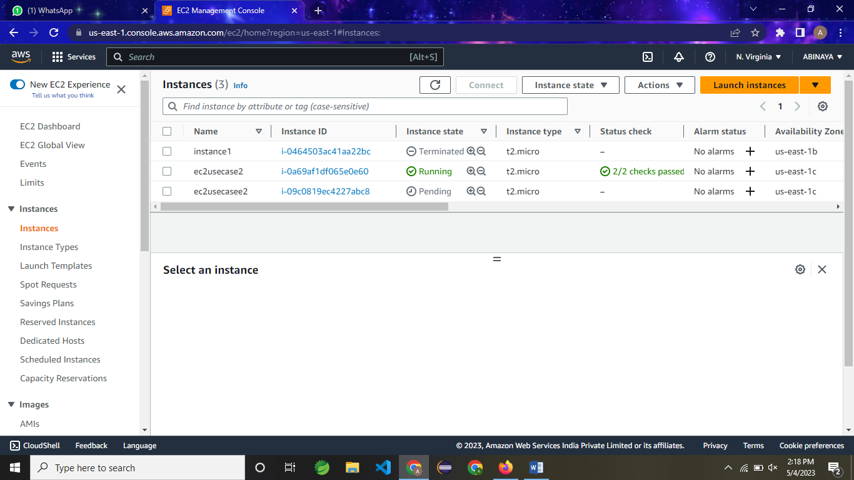

QUESTION 2

CREATE A EC2 INSTANCE IS THE GIVEN AWS ACCOUNT WITH FOLLOWING REQUIREMETS

1. IINSTANE NAME

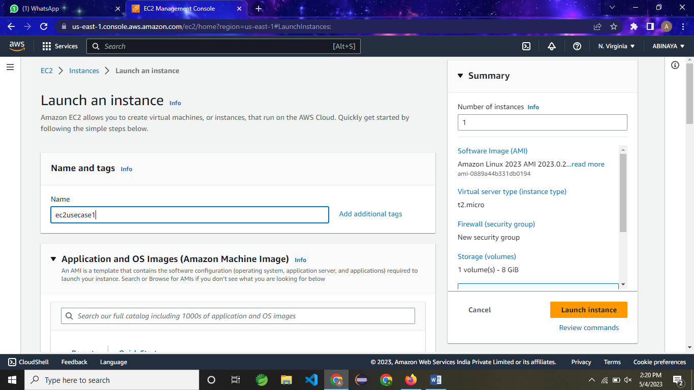

KEYPAIR NAME

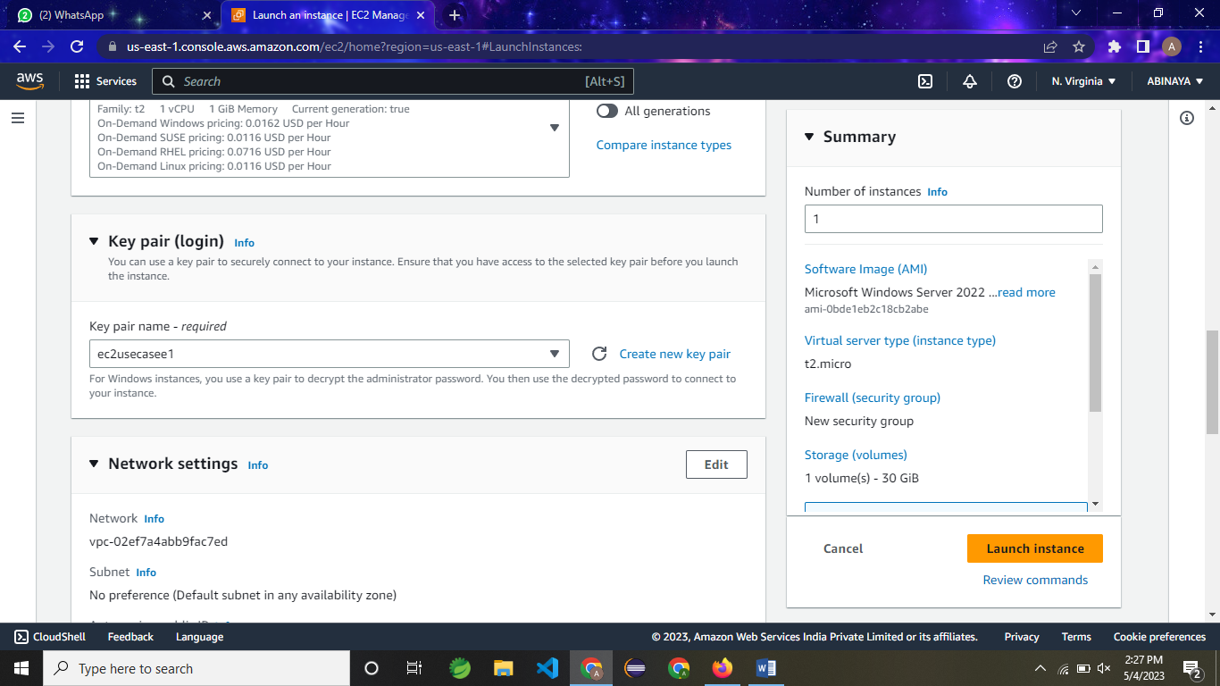

ii)

SELECT A AMI WINDOWS

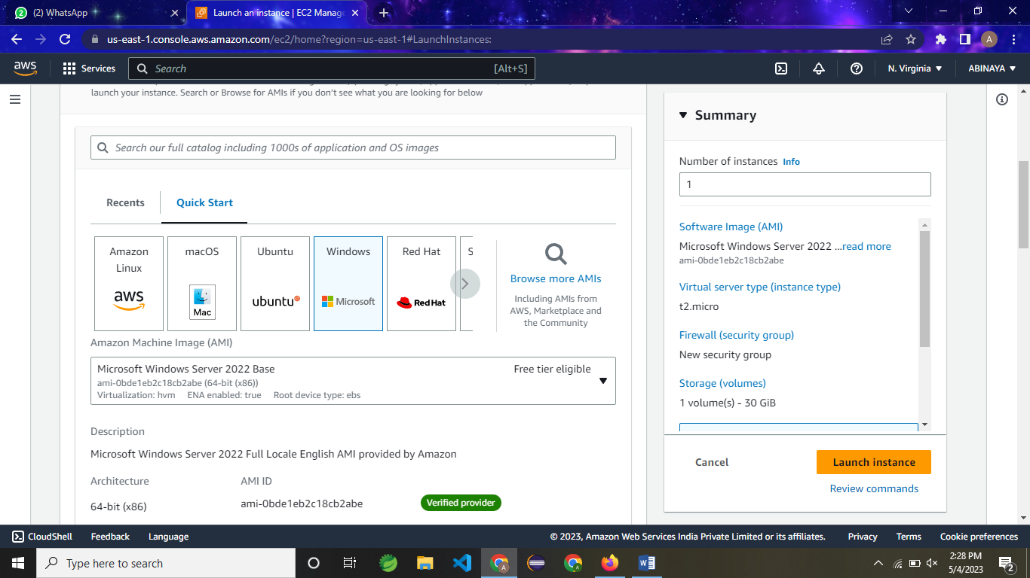

iii)

ENSURE A AUTO ASSIGNED A IP ADDRESS

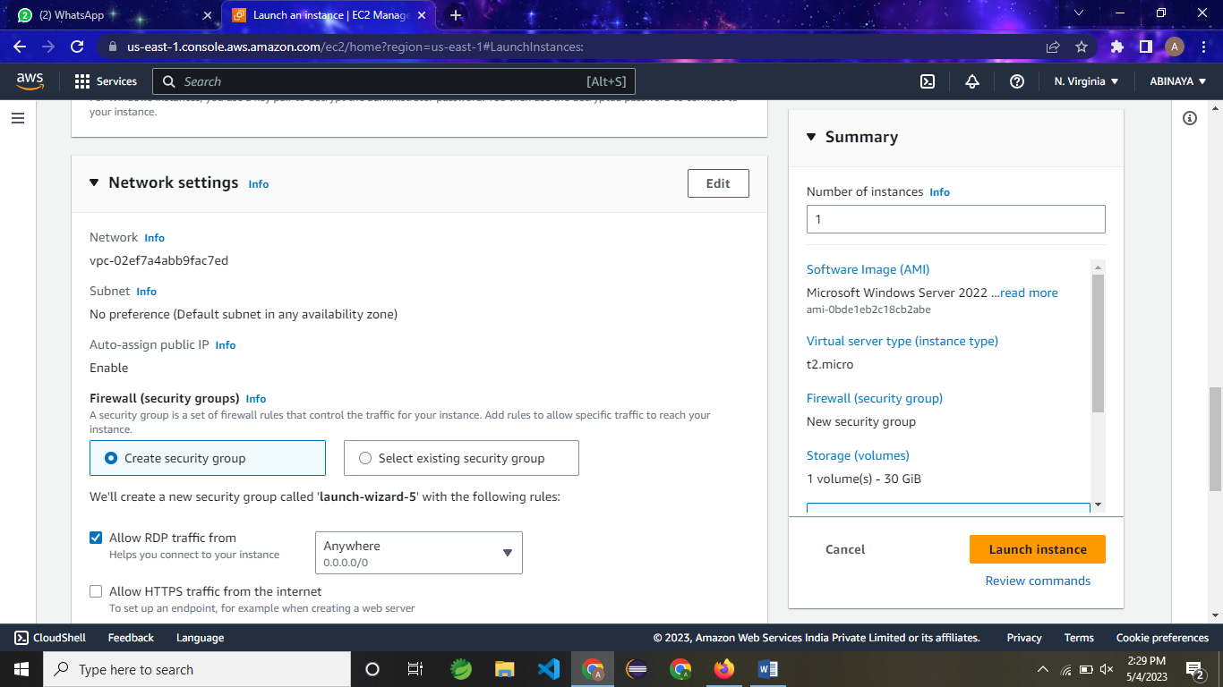

iv)

EXPORT PORT NO 3389 🡪 REMOTE DESKTOP CONNECTION

UPLOAD A PEM FILE

GET A PASSWORD

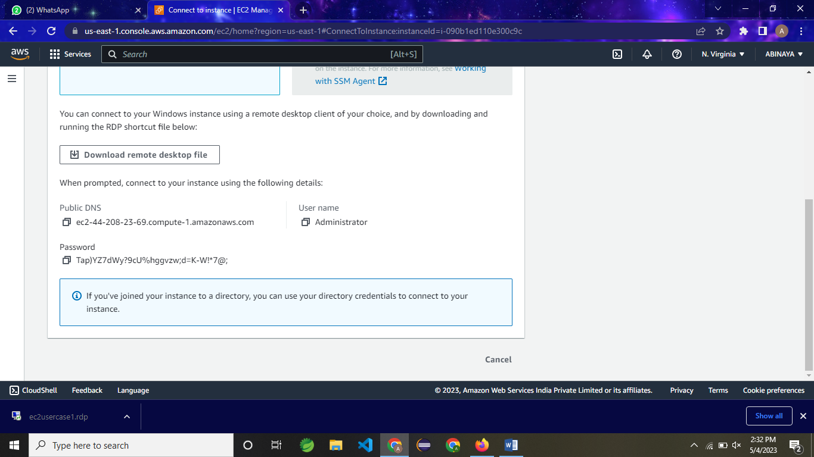

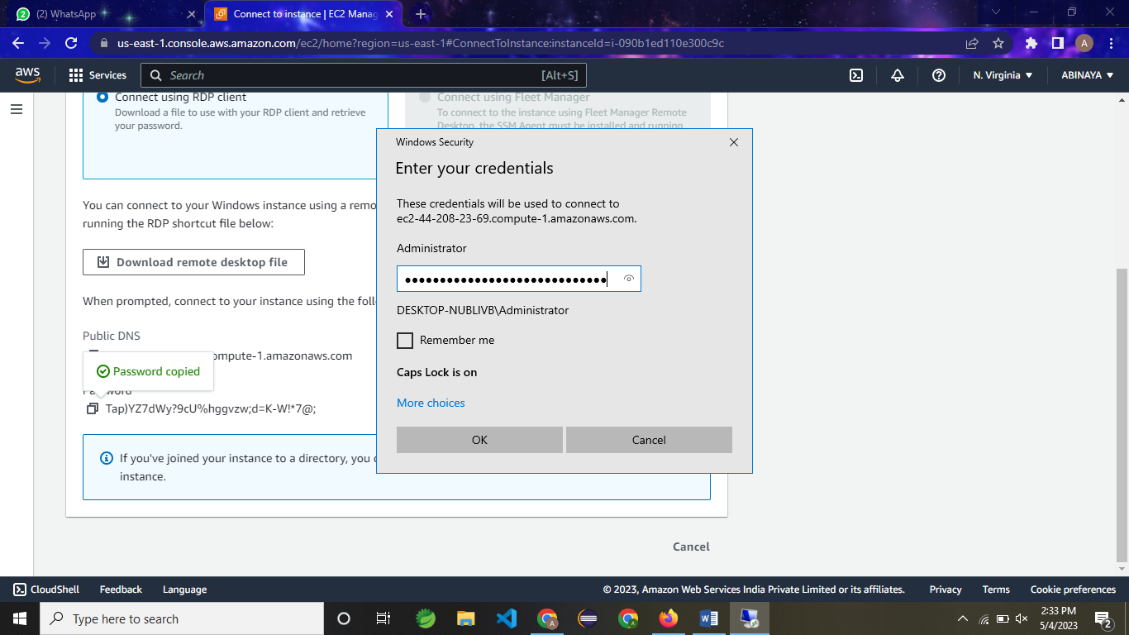

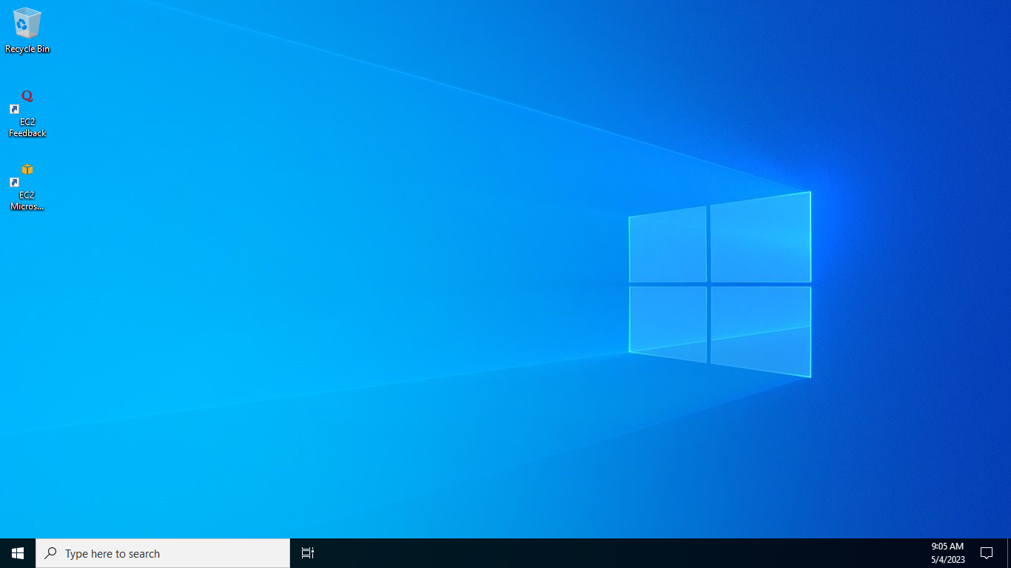

QUESTION 3

CREATE A IAM GROUP

1. GROUP NAME =>EC2-ADMINS

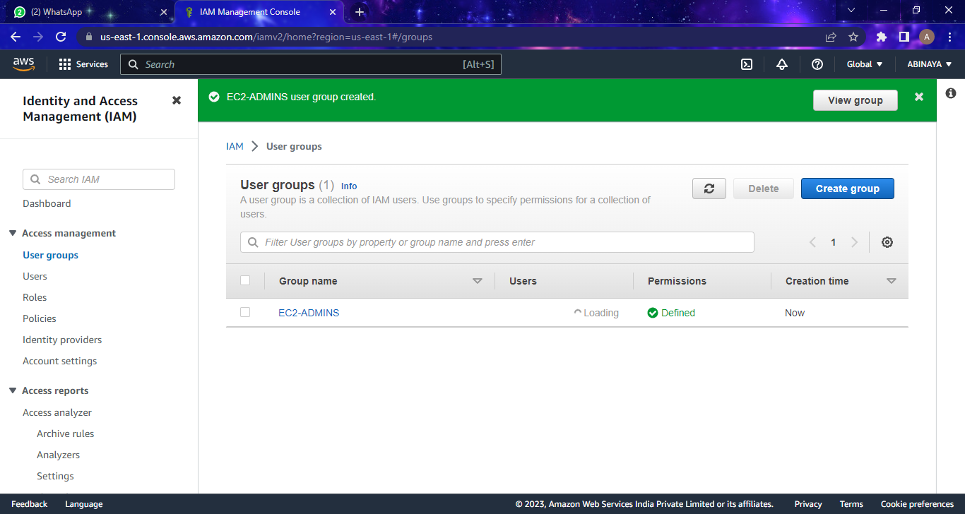

1. User name=>EC2ADMIN1

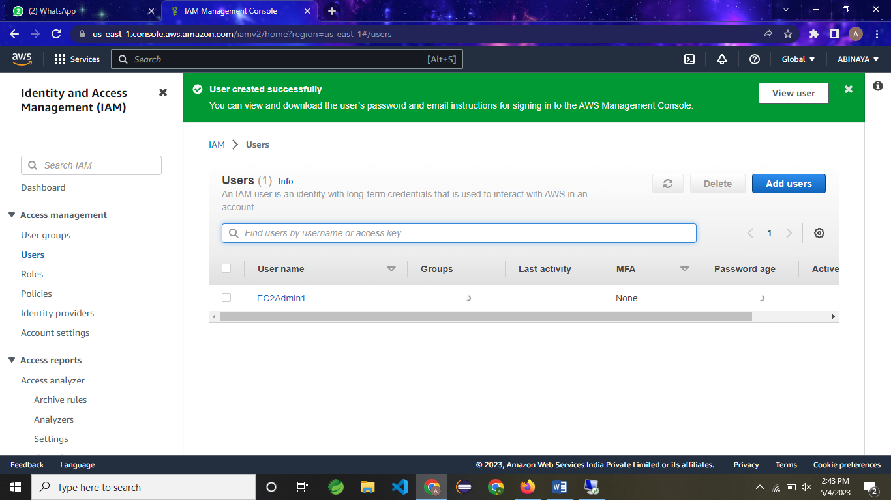

iii)POLICY ADDED

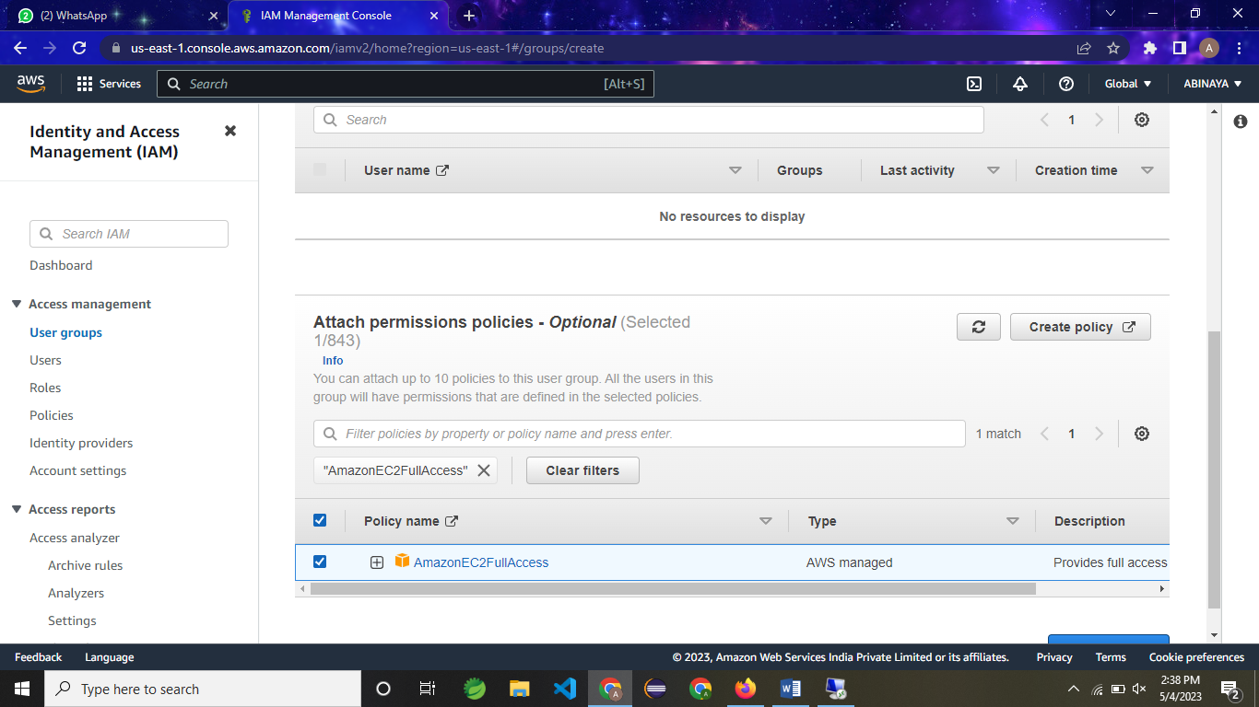

IV)

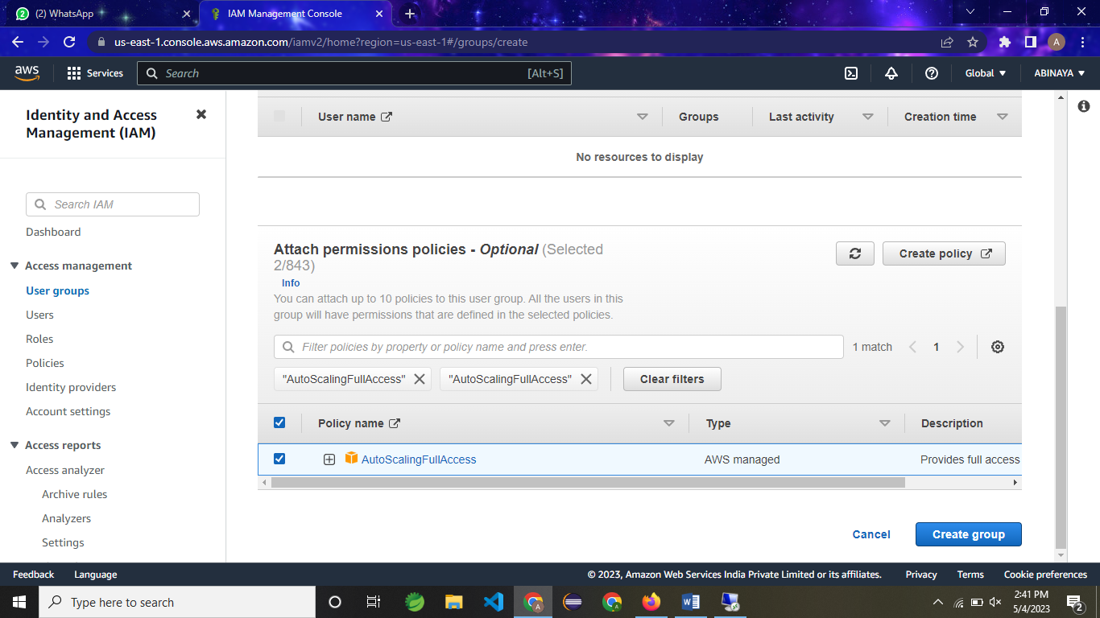

USER GROUP IS CREATED…

